Milestone 2 – Team 13

Krish Patel

Nelig Fernando

Noah Zhou

Cole Bryant

Brayden Lingelbach

Product Backlog

|  |  |  |  |  |  |
| --- | --- | --- | --- | --- | --- |
| **Order** | **ID** | **Item** | **Type** | **Status** | **Estimate** |
| **1** | The members should be able to access benefits from sponsors. | | | | |
|  | 111 | As an applicant, I want to create an account so that I can apply for DGA membership so I may receive benefits. | Functional | Done | 3 |
|  | 112 | As a member of the DGA, I want to access my current benefits package so that I may know what I am entitled to as a member. | Functional | Done | 3 |
|  | 113 | As a member of the DGA, I want to be able to request new benefits from my sponsor so I may reserve the right to request benefits. | Functional | Done | 5 |
|  | 114 | As a member, I want to be able to transfer my benefits from one sponsor to another, so they remain when I am required to change companies. | Functional | Done | 8 |
|  | 115 | As a member, I want to be able to delete my account from the database, so I may choose to join another organization. | Functional | In Progress | 2 |
| **2** | The sponsor should be able to recruit and manage members. | | | | |
|  | 121 | As a sponsor, I want to create an account so we may begin to manage the benefits of our members. | Functional | In Progress | 3 |
|  | 122 | As a sponsor of the DGA, I want to view a list of my current members within my company so that I may view/manage these members. | Functional | In Progress | 2 |
|  | 123 | As a sponsor, I want to be able to recruit members within the DGA who have not been assigned a sponsor so we can expand our company. | Functional | In Progress | 5 |
|  | 124 | As a sponsor, I want the ability to remove members from our sponsorship in necessary instances so that we may have control. | Functional | Not Started | 2 |
| **3** | Users should be able to access profile information including their email, username, phone number, and other user specific data. | | | | |
|  | 131 | As a user of the software, I would like to be able to quickly pull up profile information the system has stored on me. | Accessibility | Not Started | 5 |
|  | 132 | As a user I would like to be able to send my profile information to the product company. | Accessibility | Not Started | 2 |
|  | 133 | As a user I would like to be able to request my information sent to other sponsors, and users. | Functional | Not Started | 2 |
| **4** | A user should have easy access to help within the system such as customer support, and support forums. | | | | |
|  | 141 | As a user of the system, I would like customer support so I may receive help with my account if necessary. | Accessibility | Not Started | 3 |
|  | 142 | As a user I would like to be able to easily communicate with other users about issues that I'm having within the system. | Accessibility | Not Started | 5 |
| **5** | Sponsors should be able to manage the benefits of their members. | | | | |
|  | 151 | As a sponsor, I want to be able to add benefits to our list of members so they may receive their benefits. | Functional | In Progress | 3 |
|  | 152 | As a sponsor, I want to be able to remove benefits from members in the necessary instances where those plans aren’t feasible. | Functional | In Progress | 3 |
|  | 153 | As a sponsor, I want to have the ability to respond to requests for new plans so my members can remain satisfied with their sponsorship. | Functional | In Progress | 5 |
| **6** | The system’s web interface should be readable and accessible to all users. | | | | |
|  | 161 | As a user of the system, I want the website to have a readable UI, that way I can use the website more easily. | Accessibility | Not Started | 5 |
|  | 162 | As a user I would want quick response times from the system per my request | Performance | Not Started | 3 |
|  | 163 | As a sponsor, I want an intuitive management UI so that I can easily manage a large quantity of members. | Accessibility | Not Started | 8 |

Use case Diagram

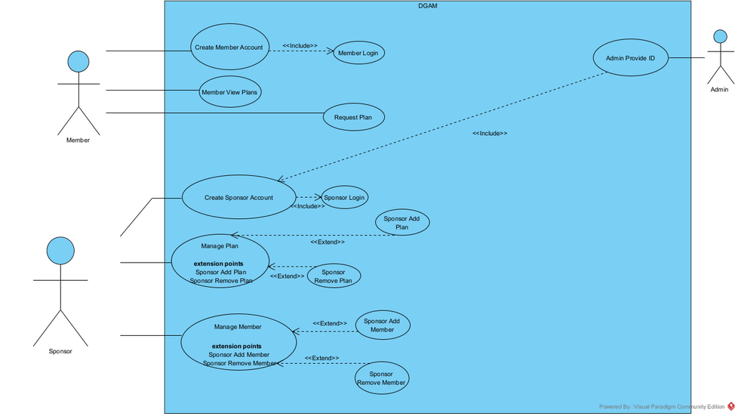

Use Case Narratives

|  |  |  |  |
| --- | --- | --- | --- |
| Use-Case Name: | Sponsor Add Member | | **Use Case Type**  **Business Requirements:**  **x** |
| Use-Case ID: | 122 | |
| Priority: | High | |
| Source: | Product Backlog | |
| primary business actor: | Sponsor | | |
| Primary System Actor: | Sponsor | | |
| Other Participating Actors: | Users | | |
| Other Interested Stockholders: | Users, and Directors Guild of America DGA | | |
| Description: | The sponsor will add members to their benefits, and plans. | | |
| Precondition: | Users must be logged in and consenting to becoming a member of the sponsor. | | |
| Trigger: | Sponsor selects a User they desire to become a member. | | |
| Typical Course of Events: | **Actor Action** | **System Response** | |
|  | 1. Sponsor selects the option to send an invite for a member ship to a specific user. | 1. Systems sends User a member add form and prompts user for reply. | |
|  | 1. User fills out form with credentials, and consent, and then accepts. | 1. The Sponsor is notified of a member added | |
| Alternate Courses: | 3a. The member denies or does not receive the notification for membership.  3b. Sponsor is notified and must resend request if necessary.  3c. Go to 1 | | |
| Conclusion: | A new member is added to the sponsor | | |
| Postcondition: | The members must keep up with the membership plan | | |
| Business Rules: | Members must make regular payments, and are provided with surveys for satisfaction within the membership | | |
| Impl. Constraints and Specifications: | N/A | | |
| Assumptions: | The has a need for new members, and will follow up on new member status | | |
| Open Issues: | N/A | | |

|  |  |  |  |
| --- | --- | --- | --- |
| Use-Case Name: | Member Remove | | **Use Case Type**  **Business Requirements:**  **x** |
| Use-Case ID: | 124 | |
| Priority: | High | |
| Source: | Product Backlog | |
| primary business actor: | Sponsor | | |
| Primary System Actor: | Sponsor | | |
| Other Participating Actors: | Users | | |
| Other Interested Stockholders: | Users, and Directors Guild of America | | |
| Description: | The sponsors will remove access to their membership plans from existing members. | | |
| Precondition: | N/A | | |
| Trigger: | Sponsor selects a member that needs to be removed from membership plan. | | |
| Typical Course of Events: | **Actor Action** | **System Response** | |
|  | 1. Sponsor selects a user that needs to be removed from the membership plan. | 1. Systems removes user from members log for sponsor and sends notification to user. | |
|  |  |  | |
| Alternate Courses: | N/A | | |
| Conclusion: | User is removed from membership plan | | |
| Postcondition: | N/A | | |
| Business Rules: | The members payment information is removed along personal information when removal of membership occurs. | | |
| Impl. Constraints and Specifications: | The user must be notified of their removal from the plan. | | |
| Assumptions: | The sponsor has a valid reason to remove the user | | |
| Open Issues: | N/A | | |

|  |  |  |  |
| --- | --- | --- | --- |
| Use-Case Name: | Admin Give ID | | **Use Case Type**  **Business Requirements:**  **o**  **System Analysis:**  **o**  **System Design:** X |
| Use-Case ID: |  | |
| Priority: | High | |
| Source: | Use Case Diagram | |
| primary business actor: | Sponsor | | |
| Primary System Actor: | Administrators | | |
| Other Participating Actors: |  | | |
| Other Interested Stockholders: | Sponsors | | |
| Description: | Sponsors will be given a unique ID once they request one from an administrator | | |
| Precondition: | Sponsors do not already have a unique ID | | |
| Trigger: | The sponsor requests a unique ID from an administrator | | |
| Typical Course Of Events: | **Actor Action** | **System Response** | |
|  | 1. The sponsor contacts an administrator for help 2. The sponsor specifies that they require a unique ID and provides necessary info 3. The sponsor replies that they have not created an account yet 4. Sponsor has now acquired unique ID and can create account | 1. The administrator replies with help options and asks for more info 2. The administrator checks info and asks the sponsor if they created an account 3. The administrator replies and gives the sponsor a unique ID that can be used in account creation 4. The administrator ends session and files support history ticket | |
|  |  |  | |
|  |  |  | |
|  |  |  | |
|  |  |  | |
|  |  |  | |
|  |  |  | |
| Alternate Courses: | 2a. If sponsor info is already found, the administrator will inform the sponsor of existing info and provide the existing unique company ID so they can login to the system | | |
| Conclusion: | The sponsor has now acquired an unique company ID that is registered in the database | | |
| Postcondition: | Sponsor can now create a new account | | |
| Business Rules: | Sponsors will need to request a unique company ID in order to create an account | | |
| Impl. Constraints and Specifications: | Sponsor does not already have a unique company ID | | |
| Assumptions: | Sponsor has not requested a unique company ID yet | | |
| Open Issues: | None | | |

|  |  |  |  |
| --- | --- | --- | --- |
| Use-Case Name: | Member Requests Plan | | **Use Case Type**  **Business Requirements:**  **X**  **System Analysis:**  **o**  **System Design:** o |
| Use-Case ID: |  | |
| Priority: | Med | |
| Source: | Use Case Diagram | |
| primary business actor: | Member | | |
| Primary System Actor: | Member | | |
| Other Participating Actors: | Sponsor | | |
| Other Interested Stockholders: | Sponsor | | |
| Description: | A member can send sponsor a request for a plan | | |
| Precondition: | Member does not have a plan | | |
| Trigger: | Member wants a plan from sponsor but does not have one | | |
| Typical Course of Events: | **Actor Action** | **System Response** | |
|  | 1. Member sends a message to sponsor about requesting a plan 2. Member provides required information 3. Member chooses specific plan | 1. Sponsor responds with confirmation and asks for member information 2. Sponsor confirms that member does not have plan and asks member to choose plan 3. Sponsor confirms that plan is available and member is now added | |
|  |  |  | |
| Alternate Courses: | 2a. Member is already part of the plan they requested  2b. Sponsor informs member is already part of plan  2c. Go to 1, sponsor asks if there is any other plan member would like to join  3a. Member is ineligible for chosen plan  3b. Sponsor informs member they are ineligible for plan  3c. Go to 1, sponsor asks if there is any other plan member would like to join | | |
| Conclusion: | Member was able to request a plan from sponsor | | |
| Postcondition: | Member has now joined a plan | | |
| Business Rules: | Members need to have created an account and joined a sponsor company | | |
| Impl. Constraints and Specifications: | Member has to be part of the database | | |
| Assumptions: | Members do not already have a plan or they want to be on another plan | | |
| Open Issues: | None | | |

|  |  |  |  |
| --- | --- | --- | --- |
| Use-Case Name: | Member Requests Plan | | **Use Case Type**  **Business Requirements:**  **X**  **System Analysis:**  **o**  **System Design:** o |
| Use-Case ID: |  | |
| Priority: | Med | |
| Source: | Use Case Diagram | |
| primary business actor: | Member | | |
| Primary System Actor: | Member | | |
| Other Participating Actors: | Sponsor | | |
| Other Interested Stockholders: | Sponsor | | |
| Description: | A member can send sponsor a request for a plan | | |
| Precondition: | Member does not have a plan | | |
| Trigger: | Member wants a plan from sponsor but does not have one | | |
| Typical Course of Events: | **Actor Action** | **System Response** | |
|  | 1. Member sends a message to sponsor about requesting a plan 2. Member provides required information 3. Member chooses specific plan | 1. Sponsor responds with confirmation and asks for member information 2. Sponsor confirms that member does not have plan and asks member to choose plan 3. Sponsor confirms that plan is available and member is now added | |
|  |  |  | |
| Alternate Courses: | 2a. Member is already part of the plan they requested  2b. Sponsor informs member is already part of plan  2c. Go to 1, sponsor asks if there is any other plan member would like to join  3a. Member is ineligible for chosen plan  3b. Sponsor informs member they are ineligible for plan  3c. Go to 1, sponsor asks if there is any other plan member would like to join | | |
| Conclusion: | Member was able to request a plan from sponsor | | |
| Postcondition: | Member has now joined a plan | | |
| Business Rules: | Members need to have created an account and joined a sponsor company | | |
| Impl. Constraints and Specifications: | Member has to be part of the database | | |
| Assumptions: | Members do not already have a plan or they want to be on another plan | | |
| Open Issues: | None | | |

|  |  |  |  |
| --- | --- | --- | --- |
| Use-Case Name: | Member View Plans | | **Use Case Type**  **Business Requirements:**  **X**  **System Analysis:**  **o**  **System Design:** o |
| Use-Case ID: | n/a | |
| Priority: | Medium/High | |
| Source: | Use Case Diagram | |
| primary business actor: | Member | | |
| Primary System Actor: | Member | | |
| Other Participating Actors: | Administrator | | |
| Other Interested Stockholders: | Sponsors | | |
| Description: | The members will be able to view the plans they have. | | |
| Precondition: | The member has an account. | | |
| Trigger: | The member accesses the member log in page | | |
| Typical Course of Events: | **Actor Action** | **System Response** | |
|  | 1. Member clicks the “member log in” button.   3. The member inputs their log in information  4. The member clicks the log in button  7. The member clicks on the “view plans” button | 1. The system changes to the log in page.   5. The system validates the credentials, and logs in the member.  6. the member is taken to their member information page.  8. The system displays the plans associated with the member. | |
|  |  |  | |
| Alternate Courses: | 5a. The system checks the credentials, but they are invalid.  5b. The system displays a message, “Invalid log in, check your information”  5c. Go to 2 | | |
| Conclusion: | The member is now viewing the plans that is available to them. | | |
| Postcondition: | The member should apply for plans through the sponsors if they want them. | | |
| Business Rules: | The member needs to apply for plans before receiving them. There are requirements and thresholds for receiving a plan. The sponsor can choose whether to give the plans or not. | | |
| Impl. Constraints and Specifications: | The member can only have plans from one sponsor. | | |
| Assumptions: | The member is linked with a sponsor. | | |
| Open Issues: | None | | |

|  |  |  |  |
| --- | --- | --- | --- |
| Use-Case Name: | Sponsor Add Plan | | **Use Case Type**  **Business Requirements:**  **x**  **System Analysis:**  **o**  **System Design:** o |
| Use-Case ID: |  | |
| Priority: | Medium | |
| Source: | Use Case | |
| primary business actor: | Sponsor | | |
| Primary System Actor: | Sponsor | | |
| Other Participating Actors: | N/A | | |
| Other Interested Stockholders: | Members | | |
| Description: | The sponsor will add a plan for their member. | | |
| Precondition: | The sponsor has a created account and one has one or more members. | | |
| Trigger: | Sponsor gets a new member. | | |
| Typical Course of Events: | **Actor Action** | **System Response** | |
|  | 1. Sponsor logs into sponsor specific account (created with SponsorID) by typing in username and password.  3. Sponsor clicks on members to view active list of members.  5. Sponsor finds specific member, and clicks “add plan”  6. Sponsor fills in required description of plan and clicks submit plan. | 2. System verifies credentials and approves sponsor to sponsor homepage.  4. System opens up page of viewers.  6. System opens up form to add plan.  7. System applies changes and saves the plan onto the specific member. | |
|  |  |  | |
| Alternate Courses: | 2a. The sponsor login request is denied due to incorrect information  7a. System can not save due to no characters being typed in the form. | | |
| Conclusion: | Sponsor adds the plan for a member. | | |
| Postcondition: | The member must honor the plan. | | |
| Business Rules: | Member makes payments on time. | | |
| Impl. Constraints and Specifications: | N/A | | |
| Assumptions: | Sponsors can have multiple members; sponsors follow up with members regarding plans. | | |
| Open Issues: | N/A | | |
| Use-Case Name: | Member Login | | **Use Case Type**  **Business Requirements:**  **o**  **System Analysis:**  **o**  **System Design:** x |
|  |  | |
| Use-Case ID: |  | |
| Priority: | High | |
| Source: | Use Case Diagram | |
| primary business actor: | Members | | |
| Primary System Actor: | Members | | |
| Other Participating Actors: |  | | |
| Other Interested Stockholders: | Admins | | |
| Description: | Members can log into their account. | | |
| Precondition: | The member is currently not logged in. | | |
| Trigger: | Member clicks the “Member Login” button. | | |
| Typical Course of Events: | **Actor Action** | **System Response** | |
|  | 1. Members select the ‘Member Login’ button. 2. Members enter their email. 3. Members enter their password. 4. Member clicks the ‘Login’ button. | 1. System brings the member to the Member Login page. 2. No direct response. 3. No direct response. 4. System checks the database for an email and password match. | |
|  |  |  | |
| Alternate Courses: | 4a. System doesn’t find an account with the associated email or password.  4b. System displays red error message saying, “Email/password incorrect.”  4c. Return to Step 2. | | |
| Conclusion: | The user is logged into their account. | | |
| Postcondition: | The user is brought to their account page. | | |
| Business Rules: | Members should be able to log into their account after account creation. | | |
| Impl. Constraints and Specifications: | The member needs to be logged into their account in order to access the features of the system. | | |
| Assumptions: | Members have already created their account. | | |
| Open Issues: | N/A | | |

|  |  |  |  |
| --- | --- | --- | --- |
| Use-Case Name: | Sponsor Login | | **Use Case Type**  **Business Requirements:**  **o**  **System Analysis:**  **o**  **System Design:** x |
| Use-Case ID: |  | |
| Priority: | High | |
| Source: | Use Case Diagram | |
| primary business actor: | Sponsors | | |
| Primary System Actor: | Sponsors | | |
| Other Participating Actors: |  | | |
| Other Interested Stockholders: | Admins | | |
| Description: | Sponsors can log into their account. | | |
| Precondition: | Sponsor is not currently logged in. | | |
| Trigger: | Sponsor clicks the “Sponsor Login” button. | | |
| Typical Course of Events: | **Actor Action** | **System Response** | |
|  | 1. Sponsor selects the “Sponsor Login” button. 2. Sponsor enters their SponsorID. 3. Sponsor enters their password. 4. Sponsor clicks the ‘Login’ button. | 1. System brings the sponsor to the login page. 2. No direct response. 3. No direct response. 4. System checks the database for an ID and password match. | |
|  |  |  | |
| Alternate Courses: | 4a. System doesn’t find an account with the associated lD or password.  4b. System displays red error message saying, “ID/password incorrect.”  4c. Return to Step 2. | | |
| Conclusion: | The sponsor is logged into their account. | | |
| Postcondition: | The user is brought to their account page. | | |
| Business Rules: | Sponsors should be able to log into their account after their account is created. | | |
| Impl. Constraints and Specifications: | Sponsors can’t access their page without logging in. | | |
| Assumptions: | Sponsors have already received their account ID and created an account. | | |
| Open Issues: | N/A | | |

|  |  |  |  |
| --- | --- | --- | --- |
| Use-Case Name: | Sponsor Remove Plan | | **Use Case Type**  **Business Requirements:**  **x**  **System Analysis:**  **o**  **System Design:** o |
| Use-Case ID: |  | |
| Priority: | Medium | |
| Source: | Use Case | |
| primary business actor: | Sponsors | | |
| Primary System Actor: | Sponsors | | |
| Other Participating Actors: | N/A | | |
| Other Interested Stockholders: | Members | | |
| Description: | Sponsor removed a plan from the member. | | |
| Precondition: | Sponsor has a sponsor account to access and has a member(s) with a current plan. | | |
| Trigger: | Sponsor needs to remove a members plan. | | |
| Typical Course of Events: | **Actor Action** | **System Response** | |
|  | 1. Sponsor logs into sponsor specific account (created with SponsorID) by typing in username and password.  3. Sponsor clicks on members to view active list of members.  5. Sponsor finds specific member, and clicks “remove plan”  6. Sponsor confirms decision to remove plan. | 2. System verifies credentials and approves sponsor to sponsor homepage.  4. System opens up page of members.  6. System gives message to confirm removal.  7. System saves and applies changes to member. | |
|  |  |  | |
| Alternate Courses: | 2a. Sponsor enters in incorrect credentials  6a. Member does not have current plan and system asks to select another member | | |
| Conclusion: | Sponsor removes plan from member. | | |
| Postcondition: | Member no longer has a plan. | | |
| Business Rules: | Sponsor gets rid of plan for correct member. Member no longer has to pay for plan they were . | | |
| Impl. Constraints and Specifications: | N/A | | |
| Assumptions: | Sponsor has member that have plans. | | |
| Open Issues: | N/A | | |

|  |  |  |  |
| --- | --- | --- | --- |
| Use-Case Name: | Sponsor View Plans | | **Use Case Type**  **Business Requirements:**  **x**  **System Analysis:**  **o**  **System Design:** o |
| Use-Case ID: | n/a | |
| Priority: | High | |
| Source: | Use Case Diagram | |
| primary business actor: | Sponsor | | |
| Primary System Actor: | Sponsor | | |
| Other Participating Actors: | Administrator | | |
| Other Interested Stockholders: | Members, Administrators | | |
| Description: | The Sponsor will be able to view the plans they are offering. | | |
| Precondition: | The Sponsor has an account | | |
| Trigger: | The sponsor clicks the “sponsor log in” button. | | |
| Typical Course of Events: | **Actor Action** | **System Response** | |
|  | 1. The sponsor clicks the “sponsor log in” button.   3. The sponsor inputs their log in information  4. The sponsor presses the “log in” button | 1. The system takes them to the log in page.   5. The system verifies their log in information and logs them in.  6. The system brings them to the sponsor information page. | |
|  | 7. The sponsor clicks the “view plans” button. | 8. The system brings them to the plan information page. | |
| Alternate Courses: | 5a. The system checks the credentials, but they are invalid.  5b. The system displays a message, “Invalid log in, check your information”  5c. Go to 2 | | |
| Conclusion: | The sponsor is able to view their plans. | | |
| Postcondition: | The sponsor will offer or has offered the plans to other members. | | |
| Business Rules: | The sponsor must pay the members the benefits listed on the plans on a monthly basis. | | |
| Impl. Constraints and Specifications: | The sponsor has a limit on plans they can offer. | | |
| Assumptions: | The sponsor has at least one plan. | | |
| Open Issues: |  | | |

Gantt Chart

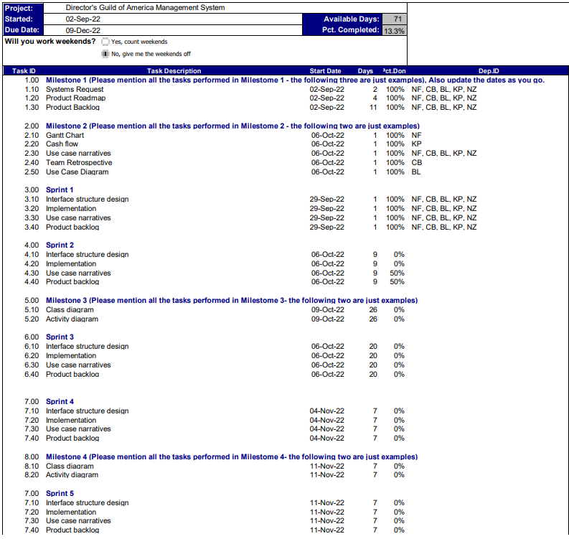

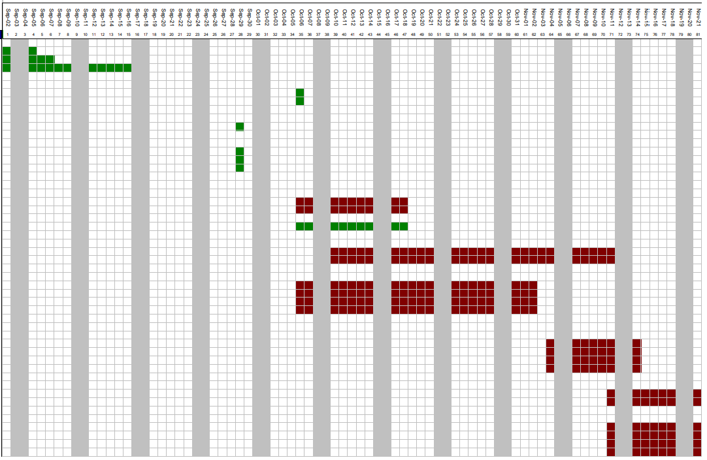

Cash Flow

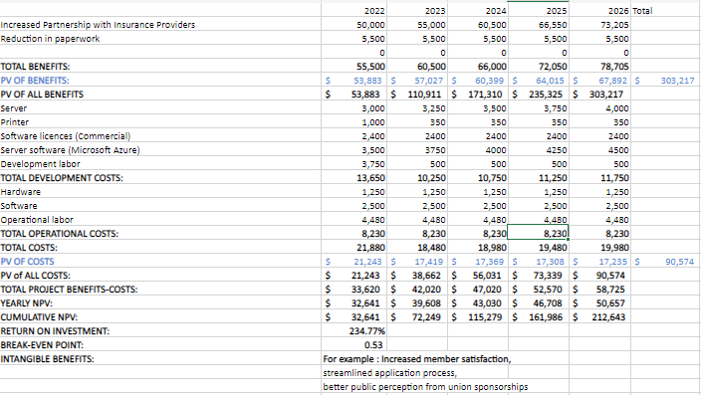

**Team Retrospective**

* Planning:
  + The team was assigned specific sections to complete for more efficiency.
  + The team designated a time on Microsoft Teams to join and coordinate together.
  + The Team used undesignated time outside of meetings to also complete work.
* Monitoring:
  + Splitting up the work increased the overall efficiency and allowed for more specific questions to be asked.
  + Using Microsoft Teams for meetings allowed questions to be easily answered.
  + Using Microsoft teams also didn’t allow as clear of communication as in person meetings.
* Evaluation
  + Use case narratives were well done with everyone doing their own ones.
  + The Product Backlog needed to be updated further than expected
* Plan of Action
  + Further refinement of the DGA system provides a clearer picture of what needs to be done.
  + More in-person meetings allow clearer communication, and less need for questions about communication issues.